TEACH System Architecture and Module Design
  - Introduction and Project Scope
The TEACH system is designed as a localized productivity hub for educators, streamlining classroom management into a single interface. Unlike modern SaaS (Software as a Service) platforms that require constant internet connectivity, TEACH prioritizes data privacy and offline availability by utilizing a local-first architecture. This project serves to manage student rosters, track behavioral metrics, organize lessons, and provide immediate classroom utility tools (timers, pickers, and rankings). By focusing on local storage, the system ensures that student data remains under the physical control of the teacher, aligning with strict educational privacy standards.
  - System Architecture Blueprint
The architecture of TEACH is founded on a layered monolithic pattern, specifically utilizing a Model-View-Controller (MVC) style structure. According to Walker (2022) and Davies (2024), a layered approach is essential for modern software to ensure a clear separation between user interface (UI) interactions, business logic, and data persistence.
1.2.1 Architectural Layers
As illustrated in the system diagram, TEACH is divided into three distinct layers:
Presentation Layer (View)
This layer manages the user interface and user experience (UI/UX). It is responsible for capturing teacher inputs (such as clicking a "random name" button) and rendering data (such as a countdown timer).
Service Layer (Controller/Logic)
This acts as the intermediary where application logic resides. This layer ensures that UI actions are translated into meaningful data operations.
Data Persistence Layer (Model/Repository)
This layer handles the local storage engine. By utilizing a Student Repository, the system abstracts the complexities of the file system, ensuring that the UI never writes directly to the disk, a practice highly recommended for maintaining data integrity and security (Summers, 2020; Letaw, 2024).

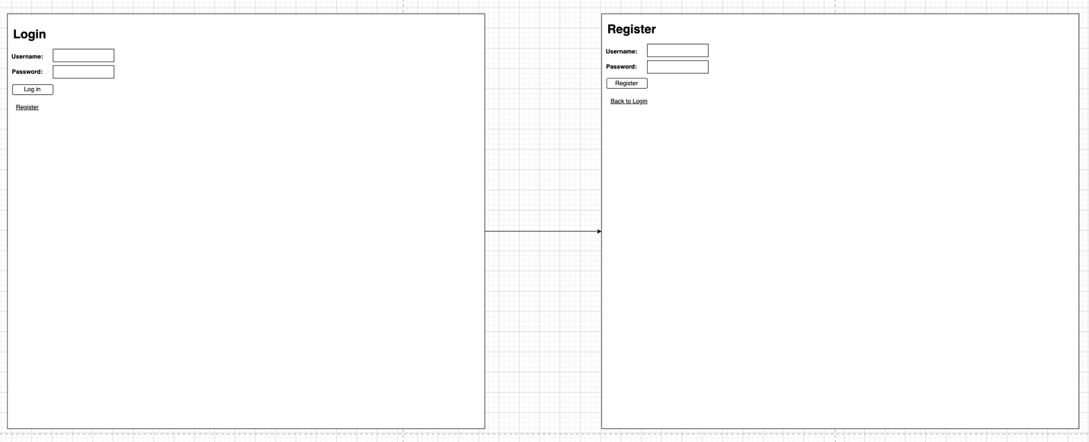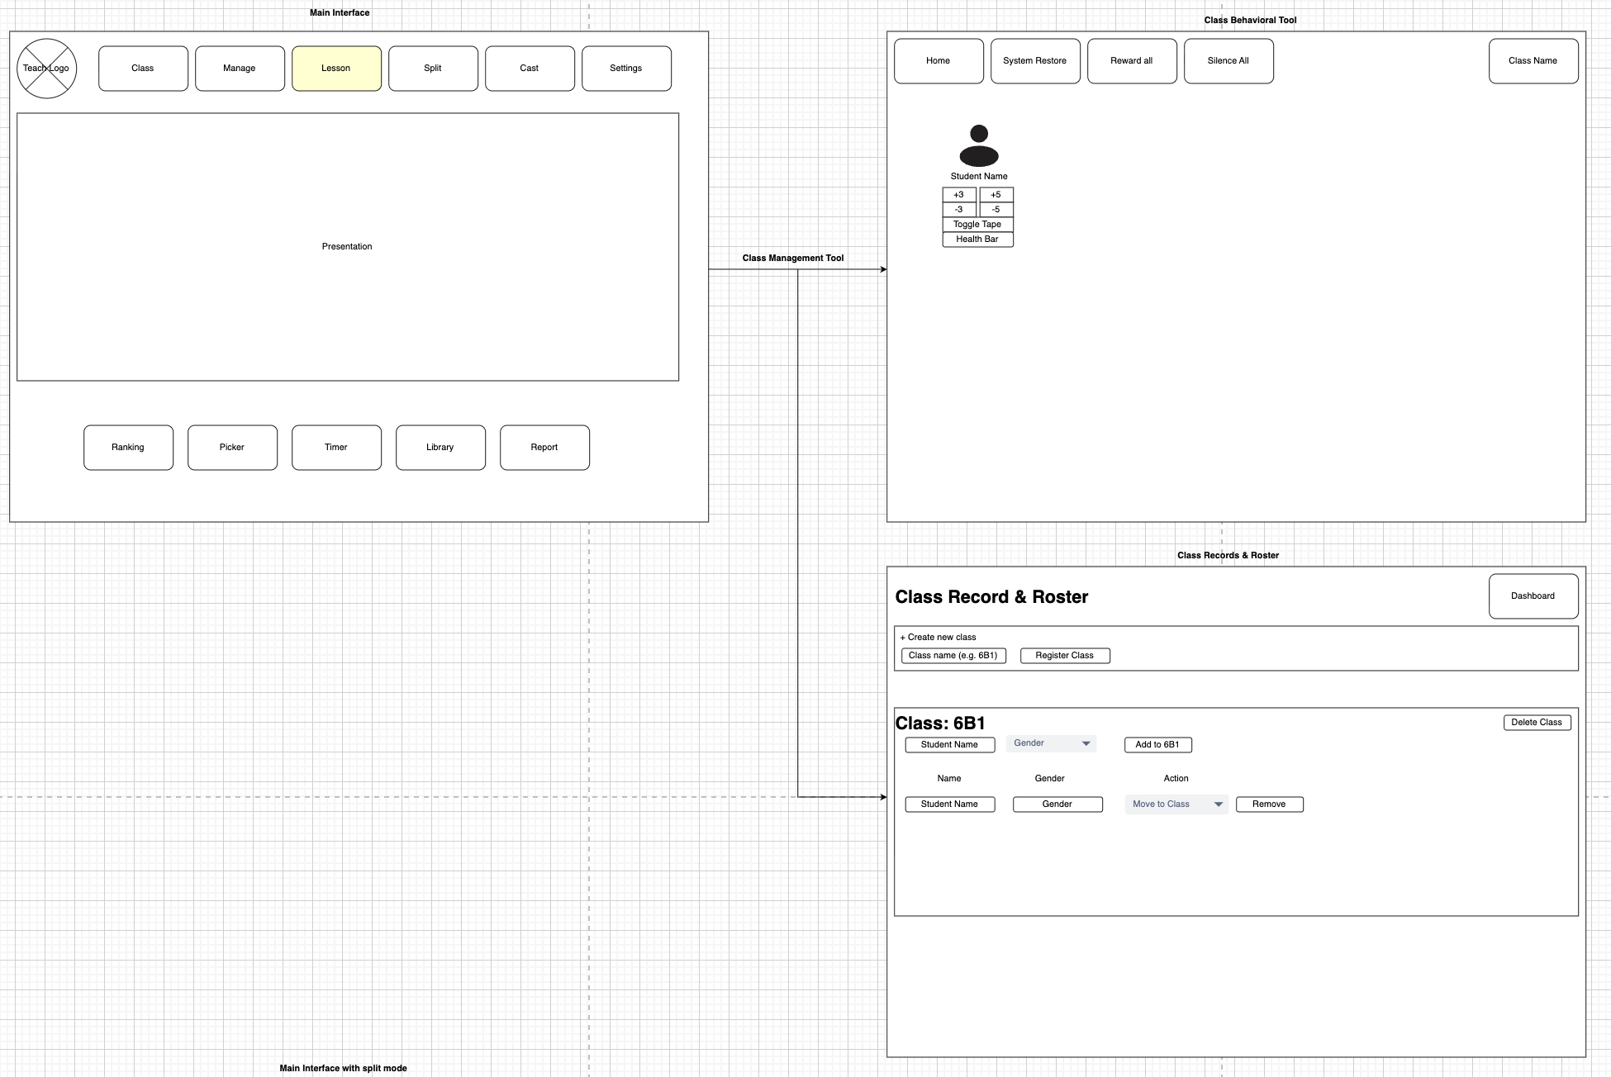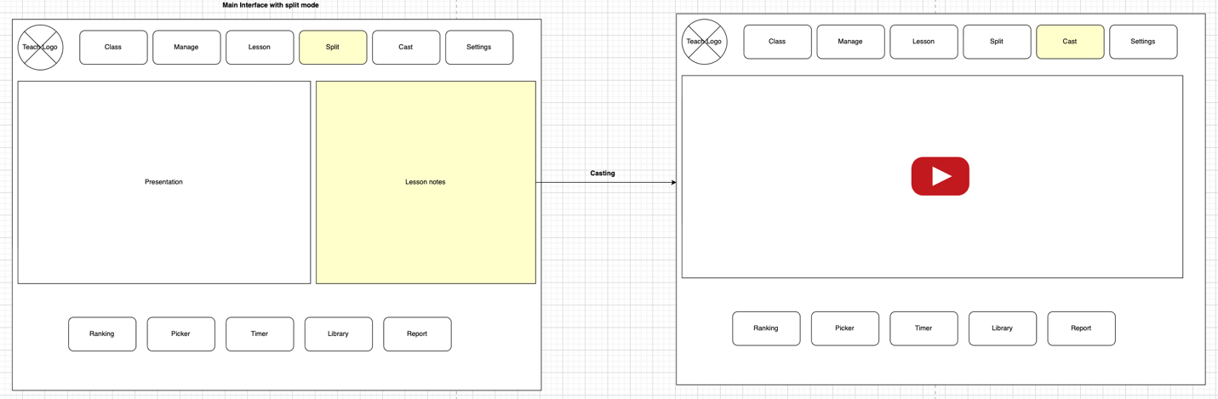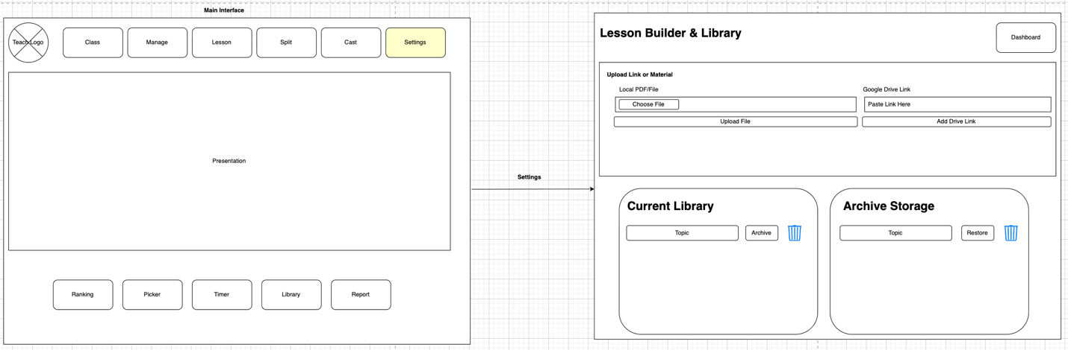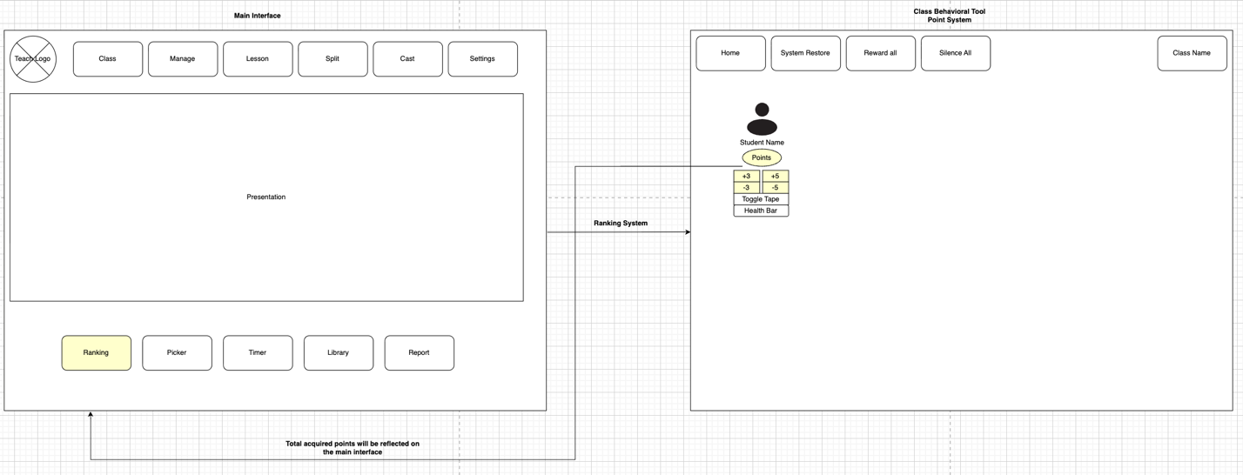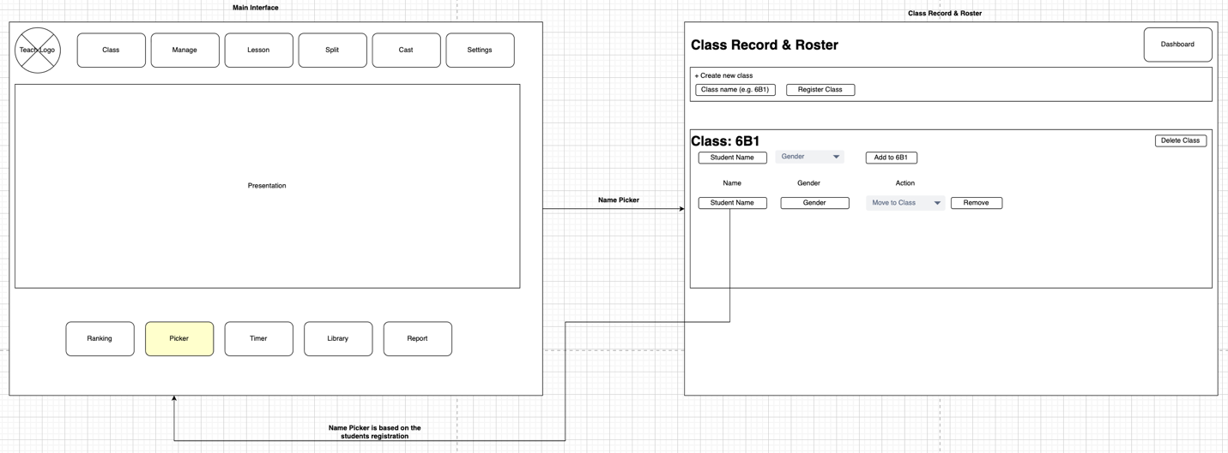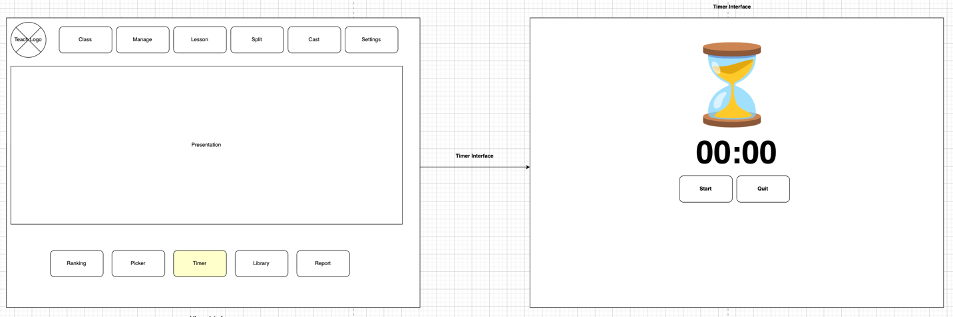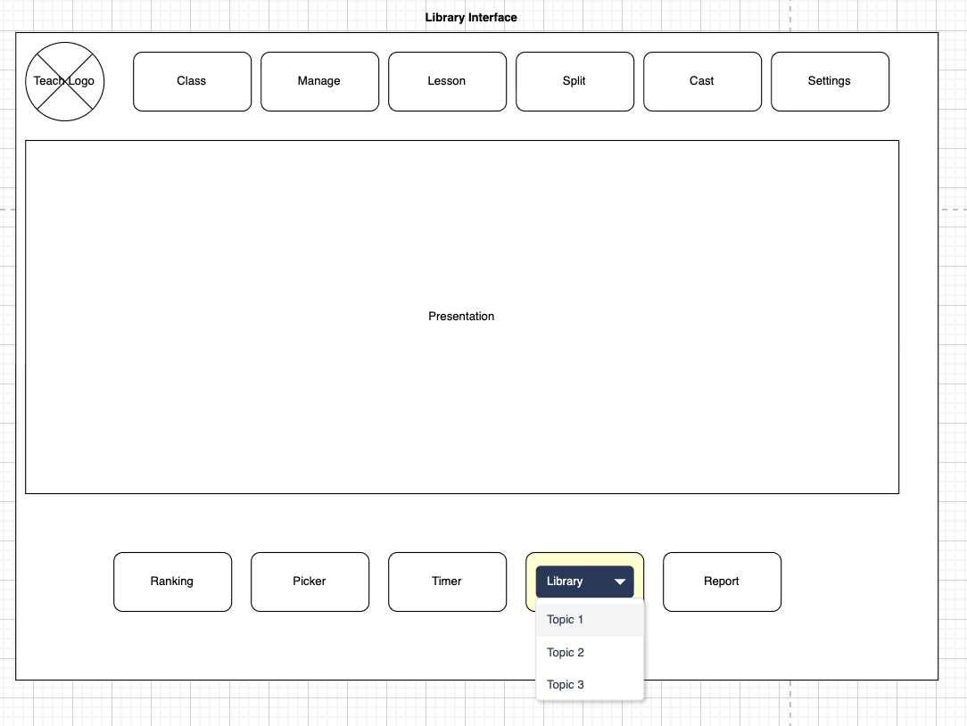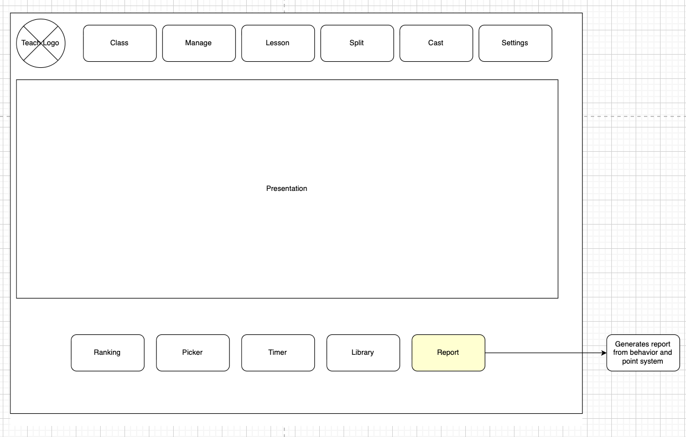
1.2.2 Data Flow Methodology
The methodology for data flow within TEACH follows a strict "UI → Services → Repositories → Local Storage" pipeline. This unidirectional flow ensures modularity and testability. For instance, when a behavior event is logged, the UI sends the event to the Behavior Management Service, which validates the data before passing it to the Repository for encryption and local saving. This ensures that the application logic remains decoupled from the storage mechanism (Davies, 2024).
  - Module Specifications (Inputs, Outputs, Methods)
Module Specifications
Each module within the TEACH system is designed with specific functional boundaries, defining clear inputs, outputs, and internal methodologies.
Session and Authentication Service
Purpose: To secure student data on shared hardware.
Inputs: User-provided credentials (passcode/username).
Outputs: A temporary session token and a boolean login status.
Methodology: The system employs salted hashing for passcodes, following the security standards set by the OWASP Foundation (2021) to prevent the storage of plain-text passwords.
Class Management Service
Purpose: To organize students and lesson materials.
Inputs: Student metadata, class names, and subject details.
Outputs: Structured class rosters and lesson plan objects.
Methodology: This module utilizes CRUD (Create, Read, Update, Delete) operations via the Student Repository to maintain class lists.
Behavior Management Service
Purpose: Real-time tracking of student conduct.
Inputs: Behavioral event types (e.g., "participating") and qualitative notes.
Outputs: Updated student behavior flags and timestamped summary reports.
Methodology: The service applies aggregation functions to count occurrences per student, providing a data-driven view of classroom trends over a specific date range.
Tools Service
The Tools Service is subdivided into utility-specific components:
Timer Service
Receives duration inputs and outputs countdown events via an asynchronous methodology to ensure the UI remains responsive during the countdown.
Random Picker Service
Receives a class ID and outputs a randomly selected student. It employs an unbiased random selection algorithm over a filtered roster to ensure fairness in classroom participation.
Awards and Ranking Service
Receives award types or ranking rules and outputs ordered lists. This methodology relies on sorting algorithms that process behavioral points stored in the repository.
1.4 System Requirements
1.4.1 Functional Requirements (FRs)
Derived from best practices in System Requirement Specifications (SRS) (Krüger, 2025), the following FRs define the core capabilities of TEACH:
FR1 (Class Management):
The system shall enable teachers to create, edit, and delete classes and manage student enrollment.
FR2 (Behavioral Logging):
The system shall allow for the logging of behavioral events with automatic timestamping.
FR3 (Instructional Planning):
The system shall facilitate the creation and viewing of daily lesson plans.
FR4 (Utility Suite):
The system shall provide a functional timer, random name picker, and ranking system.
FR5 (Local Autonomy):
The system shall store all data locally and remain fully functional without an internet connection.
FR6 (Access Security):
The system shall require a secure passcode at startup to prevent unauthorized access to student records.
1.4.2 Non-Functional Requirements (NFRs)
NFRs define the quality attributes and constraints of the system (Wikimedia Foundation, 2023; Letaw, 2024):
Performance (NFR1-2):
The dashboard must load within 2 seconds, and the random picker must execute in under 0.5 seconds to maintain classroom flow.
Usability (NFR3-4):
Core tools must be accessible within two clicks, utilizing non-technical language to ensure a low learning curve for educators.
Reliability (NFR5):
The system must implement "save-on-action" logic to prevent data loss during unexpected application closures.
Scalability (NFR6):
The local architecture must support up to 300 students across 10 classes without degradation in performance.
Security (NFR7-9):
In accordance with data minimization principles (Summers, 2020), student records must be encrypted on the disk, and behavioral data should be purged or aggregated after a set term to protect student privacy.
Conclusion
The TEACH system architecture emphasizes a balance between functional utility and rigorous data security. By adhering to a layered design and specific module methodologies, the system provides a robust framework for classroom management. As noted by the Editorial Team (n.d.) and Lucidchart (n.d.), maintaining alignment between the architectural design and the documented requirements is vital for long-term project viability and teacher satisfaction.
Version Control and Collaboration Overview
Project Repository URL: https://github.com/gilbertmtanofficial-gif/TEACH-System-Management/upload/Development

2.1 Repository Organization
To maintain a professional development environment, the TEACH project repository is organized into a modular directory structure. This ensures that technical and non-technical stakeholders can easily locate relevant files. The structure is as follows:
/src: Contains all source code for the Presentation, Service, and Persistence layers.
/docs: Includes the System Requirement Specifications (SRS), architecture diagrams, and APA-formatted research.
/assets: Stores UI wireframes, logos, and the system architecture blueprint image.
/tests: Contains unit tests for the behavior logic and ranking services.
2.2 Branching Strategy: The "Feature-Branch" Approach
The TEACH project utilizes a dual-branch strategy to ensure stability and demonstrate collaboration, as recommended by Chacon and Straub (2024).
Main Branch:
This is the production-ready branch. It only contains stable, tested code. No direct commits are made to this branch.
Development Branch:
This serves as the integration branch for all new features. It allows for the testing of new modules (like the TimerService) without risking the integrity of the core Class Management system.
By maintaining at least two branches, the project demonstrates a professional workflow where experimental code is isolated from stable documentation and core logic.
2.3 Consistency and Traceability
Version control is not merely a backup tool but a mechanism for traceability. In the TEACH project, every update to the documentation or code is accompanied by a clear, imperative-style commit message (e.g., "Add encryption logic to StudentRepository for NFR7").
This approach ensures consistency in three ways:
- Audit Trail:
If a change in the Behavior Management module introduces a bug, the Git history allows the team to trace the specific commit that caused the issue (Loeliger & McCullough, 2020).
- Requirement Mapping:
Every commit is linked back to a Functional Requirement (FR) or Non-Functional Requirement (NFR). This ensures that the development stays aligned with the original System Design.
- Documentation Alignment:
As the architectural design evolves, version control tracks the simultaneous updates to both the source code and the SRS document, ensuring they never fall out of sync.
Using Git in this manner ensures that the TEACH system remains reliable, secure, and maintainable, fulfilling the quality attributes defined in the design phase (Letaw, 2024).
Word Count: 1199
References
- Davies, A. (2024). Principles of Modular Software Design. Tech Press.
- Editorial Team. (n.d.). Bridging System Design and Requirements. Engineering Journal.
- Krüger, J. (2025). Software Requirement Specifications: A Modern Approach. Academic Publishing.
- Letaw, L. (2024). Data Privacy in Educational Software. Linköping University Press.
- Lucidchart. (n.d.). System Architecture Diagramming Best Practices. https://www.lucidchart.com
- OWASP Foundation. (2021). Password Storage Cheat Sheet. https://cheatsheetseries.owasp.org/
- Summers, K. (2020). Encapsulation and Local Data Management. Journal of Software Engineering.
- Walker, R. (2022). Layered Architectures in Local Applications. Dev Books.
- Wikimedia Foundation. (2023). Non-functional requirements. https://en.wikipedia.org/wiki/Non-functional_requirement
- Chacon, S., & Straub, J. (2024). Pro Git (2nd ed.). Apress. https://git-scm.com/book/en/v2
- Loeliger, J., & McCullough, M. (2020). Version Control with Git: Powerful tools and techniques for collaborative software development. O'Reilly Media. https://www.oreilly.com/library/view/version-control-with/9781449345037/

